Lab Report-1

Name: Mahmud

ID: 181-15-1862

Experiment: 01

Experiment Name: Length of string in C language .

Code:

#include<stdio.h>

int main()

{

char s1[20];

int i,len=0;

printf("Enter a String : ");

gets(s1);

for(i=0;s1[i]!='\0';i++){

len++;

}

printf("\nString Length: %d\n",len);

return 0;

}

Output:

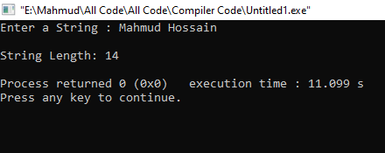

Discussion:

At first, define an array for put a string.

Use a gets function for taken user input.

Then find the length of string used for the loop.

Experiment: 02

Experiment Name: String reverse in c

Code:

#include<stdio.h>

int main()

{

char s[40],s1[40];

int i,j,len=0;

printf("Enter a String : ");

gets(s);

for(i=0;s[i]!='\0';i++){

len++;

}

for(i=len-1,j=0;i>=0;i--,j++){

s1[j]=s[i];

}

s1[len]='\0';

printf("Reverse String : ");

puts(s1);

return 0;

}

Output:

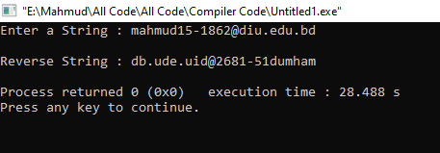

Discussion:

At first, define two array s, s1.

Use a gets function for taken user input.

Then find the length of string used for loop.

Again use a loop for string character swap one by one from last to the first index.

Reverse string put into array s1.

At last print array s1.

Experiment: 03

Experiment Name: Two string concatenation in c

Code:

#include<stdio.h>

int main()

{

char s1[30],s2[30];

int i,j,len=0;

printf("Enter 1st String : ");

gets(s1);

printf("Enter 2ND String : ");

gets(s2);

for(i=0;s1[i]!='\0';i++){

len++;

}

for(i=len,j=0;s2[j]!='\0';i++,j++)

{

s1[i]=s2[j];

}

s1[i]='\0';

printf("\nTwo string Concatenate : ");

puts(s1);

return 0;

}

Output:

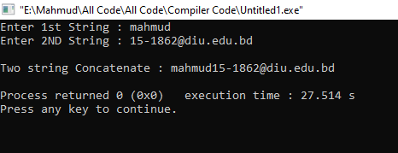

Discussion:

At first, define two array s1, s2.

Use a two gets function for taken user input.

Then find the length of string s1 used for loop.

Again use a loop to add second-string add with the first string.

Two strings are put into array s1.

At last print array s1.

Experiment: 04

Experiment Name: Write a program to compare two strings. If the two strings are same, print "Same", otherwise print "Not Same".

Code:

#include<stdio.h> int main()

{

char s1[20],s2[20]; int i,j,len1=0,len2=0,cmp1=0,cmp2=0; printf("Enter 1st String : "); gets(s1); printf("Enter 2nd String : "); gets(s2); for(i=0;s1[i]!='\0';i++){ len1++;

}

for(j=0;s2[j]!='\0';j++)

{

len2++;

}

if(len1!=len2){ printf("\n Not Same \n\n");

}else{ for(i=0,j=0;i<=len1-1;i++,j++){ if(s1[i]==s2[j]){ cmp1++;

}else{ printf("\n Not Same \n\n"); break;

}

}

if(len1==cmp1){ printf("\n Same \n\n");

}

}

return 0;

}

# Output

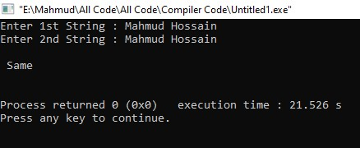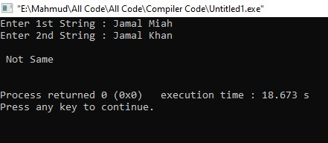

Discussion:

At first, define two array s1, s2.

Use a two gets function for taken user input.

Then find the length of both strings used for loop.

Compare string length with string one and two.

If both strings are not equal easy to find they are not same.

Otherwise

Use a loop to compare string character by character .

Experiment: 05

Experiment Name: Write a program to find out whether a string is a Palindrome string or not.

Code:

#include<stdio.h> int main()

{

char s1[40],s2[40]; int i,j,len=0,len1=0,len2=0,cmp1=0,cmp2=0;

printf("Enter a String : "); gets(s1);

for(i=0;s1[i]!='\0';i++){ len++;

}

for(i=len-1,j=0;i>=0;i--,j++){ s2[j]=s1[i];

}

s2[len]='\0';

for(i=0;s1[i]!='\0';i++){ len1++;

}

for(j=0;s2[j]!='\0';j++)

{

len2++;

}

if(len1!=len2){ printf("\n Not Same \n\n");

}else{ for(i=0,j=0;i<=len1-1;i++,j++){ if(s1[i]==s2[j]){ cmp1++;

}else{

printf("\n String is not Palindrome \n\n");

break;

}

}

if(len1==cmp1){

printf("\n String is Palindrome \n\n");

}

}

return 0;

}

# Output

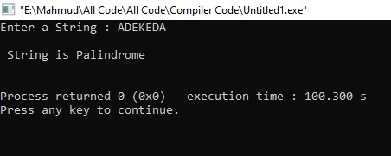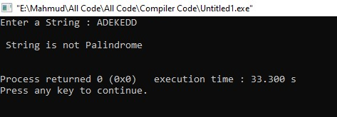

Discussion:

At first, define two array s1, s2.

Use a gets function for taken user input.

Then find the length of strings s1 used loop.

S1 string was reversed for the check string palindrome.

And reverse string put into S2 array.

At last compare two string s1 and reverse string s2 character by character.